My goal for the 2021 Fall Semester was to create an 8x8x8 LED matrix. Not only would this be a fun project, but I was going to turn in the final product for a class I was taking.

To begin, I decided to make a 4x4x4 matrix to understand the principles that I would need to understand when making the bigger design. I spent a weekend creating the template I would use for the 4x4x4 matrix and soldering together the four layers. I used 18-gauge wire to connect the LEDs and used the insulation of the wires to protect shorts between layers and columns from occurring. With some wire wrap wires, a protoboard, and an Arduino Nano, I was able to create a working, programmable 4x4x4 LED matrix.

Once I felt confident I understood how the 4x4x4 matrix worked, I began the process of soldering 512 LEDs into eight layers for the 8x8x8 matrix. I used a piece of wood and a nail to bend the LED leads to make the assembly easier. Preparing all 512 LEDs, along with my school studies, took about two weeks. Once that was complete, I used a larger template that I had made to solder together each layer. Again, I used 18-gauge wire and the wire insulation to prevent shorts to create the sturdy frame.

Creating all eight layers took about a month. Once they were complete, I was able to stack them on top of each other to make the cube in a couple of days.

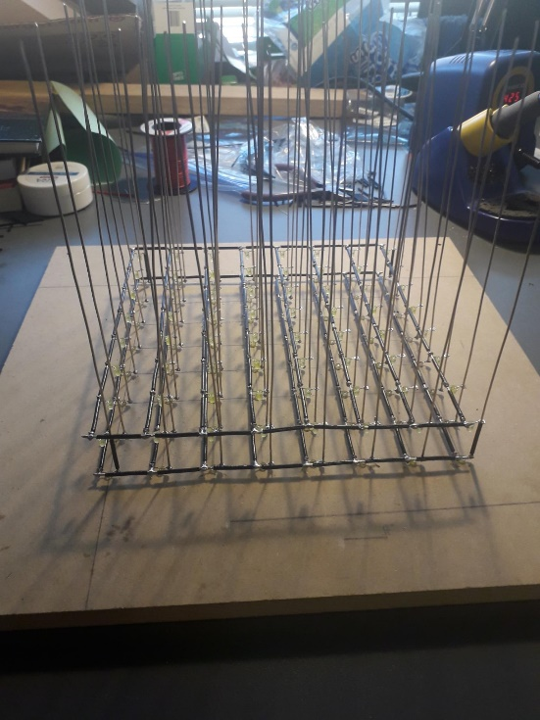

Once the physical cube was created, I needed to create a circuit that would turn on the LEDs with an Arduino Nano in programmable patterns. This where I began to run into problems. I had gotten this design from a youtuber and was trusting that what he had created and shared was functional. I was able to create a PCB on Eagle with the schematic that he had shared in his video’s description. He decided to use eight 74HC595 shift registers for the 64 columns and a ninth shift register to control each layer. I decided to go with that design because it seemed to be the most efficient way to use the Arduino Nano’s 14 I/O pins.

Furthermore, I opted to use my colleges PCB printer to create my circuit board. Something that I looked over was that I accidentally made the pitch of the wires too thin. This made the margin of error while soldering the pieces to the board very small. Because the deadline for the project was approaching, I could not print another board. I had to go with the board I had already made.

Once I assembled the entire board, I found that the pins the youtuber had specified in his schematic did not correlate with the pins the default Arduino library uses to run shift registers. His design was bad. My only options were to create my own library to compensate for this problem or to create my own design.

At this point of the semester, I had no time to work on the project anymore. I needed to study for finals and do well in my other classes. I spoke with my professor, and he was very impressed with what I had already done and assured me that I did not need to finish the project to get an A in his class. So, I decided to forgo finishing the project to get good grades in the rest of my classes.

Instead of creating my own library, I want to create a new design for the board. I need to understand how to use the 74HC595 shift register better before I program anything. So, I am currently working on understanding how to concatenate and then program nine shift registers for my 8x8x8 LED matrix. The plan is to use a protoboard and wire wrap wires like in the 4x4x4 matrix I made and create a box to house the large LED matrix to display in my apartment. The goal is to have this finished by the end of January.